Art style for the robot stealth game: Noodle-bot

Theme and general things for the art and design:

* 3D, but top view (3D tile mapping in Unity)
* The theme is robots
  + A very modern lab
  + Detective/office vibes (gunpoint)
  + Warehouse (for boxes and other objects to hide behind)

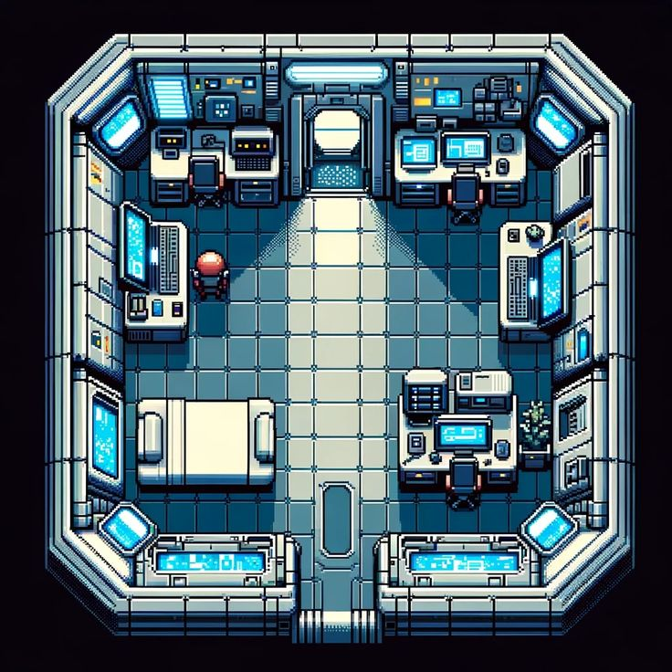

This is what I imagine it will be like when we talk about a top view game. The white/gray color combines with hints of blue everywhere to make it feel like theme robots and tech would be quite suitable for the game.

Stealth game example: Gunpoint. It was highly recommended by my friend. Sideview, but things that we can take as inspiration is servers, databases, automatic doors, and sensors (to use for puzzle-solving mechanics). The ‘gimmick’ of this game is that the main character is a hacker and can connect arbitrary sensors to other outlets, such as a door, enabling the player to creatively kill enemies.

Another room that can be used for inspiration. A warehouse/storage system or something could fit the overall theme. This is not a warehouse or anything, but the containers and objects in this picture can be yoinked for inspo.

The art style for the game

* We will use 3d tile mapping and I am inexperienced in game art design.
* Low poly 3d art (A short hike)
* Minimalistic, moody atmosphere, with a lot of dark and shadowy environments. The color palette will be darker tones and muted with bits of light blue lights coming off the devices to create a futuristic atmosphere.
* Cartoonish (Mark of the ninja) or like the two robot designs below (4 legs and yellow), to keep it simple.

Robot designs

* Needs to have legs for the stealth
* An antenna to indicate the volume of the sound that the character makes in
* Simple and dumb-looking to fit the noodle arms lmao

The position of the antenna is pretty cool and he is kind of cute. However, he has 4 legs and no arms…

The texture is really good and the way the legs are made is creative, but too much detail in the texture. My blender skills are too bad.

Low-quality, simple